C-DAC Mumbai Lab Assignment-4
C-DAC MUMBAI
Name: Mohit Patil | Batch : Aug 2026
Course : Advance Computing | Date Of Submission: 23/08/2026

Question 1: Print Numbers from 1 to N

Problem Statement:
Write a Java program that asks the user for a number N and then prints the numbers from 1 to N using a for loop.

Sample Input:
Enter a number: 10
Expected Output:
1 2 3 4 5 6 7 8 9 10

Code:

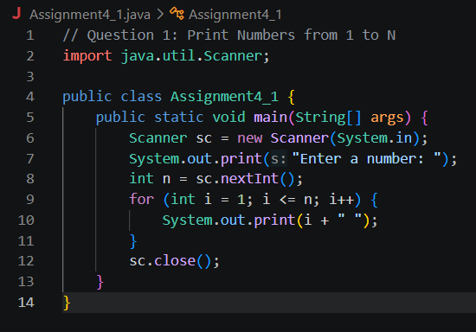

Question 2: Print Multiples of 3 between 1 and N

Problem Statement:
Write a Java program that asks the user for a number N and prints all the multiples of 3 between 1 and N using a for loop.

Sample Input:
Enter a number: 20

Expected Output:
3 6 9 12 15 18

Code:

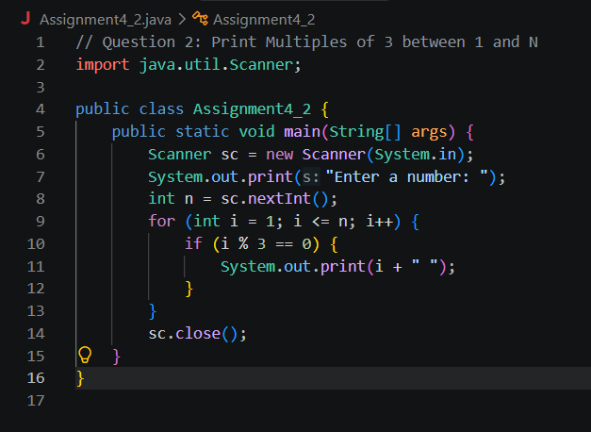

Question 3: Calculate the Factorial of a Number

Problem Statement:
Write a Java program that asks the user for a number N and calculates the factorial of N using a for loop.

Sample Input:
Enter a number: 5

Expected Output:
Factorial of 5 is 120

Code:

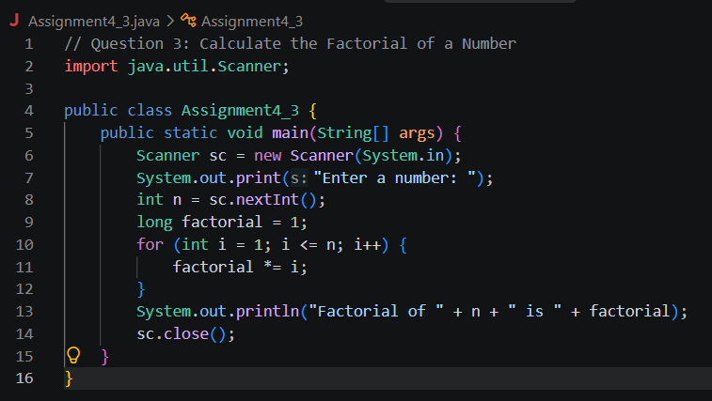

Question 4: Print Even Numbers from 1 to N

Problem Statement:
Write a Java program that asks the user for a number N and prints all the even numbers from 1 to N using a for loop.

Sample Input:
Enter a number: 10

Expected Output:
2 4 6 8 10

Code:

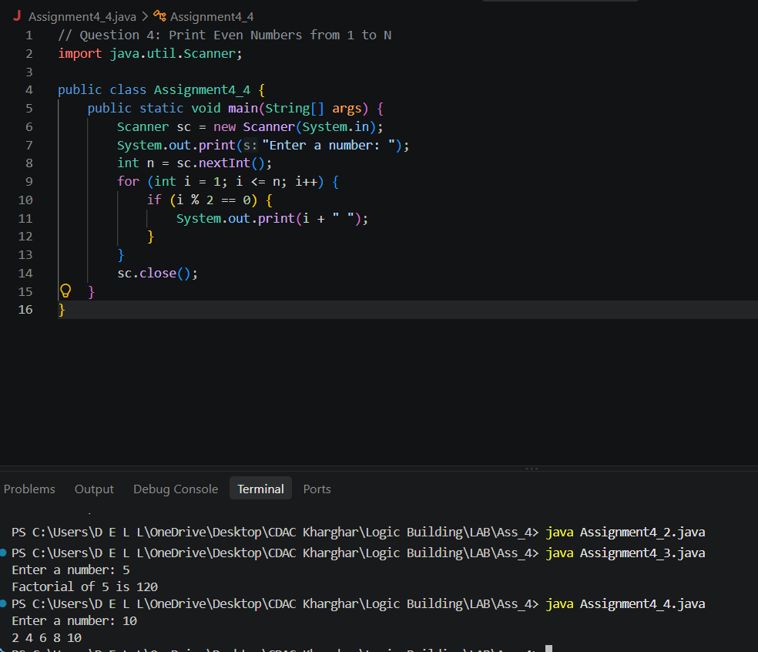

Question 5: Sum of Odd Numbers between 1 and N

Problem Statement:
Write a Java program that asks the user for a number N and calculates the sum of all odd numbers between 1 and N using a for loop.

Sample Input:
Enter a number: 10

Expected Output:
The sum of odd numbers from 1 to 10 is: 25

Code:

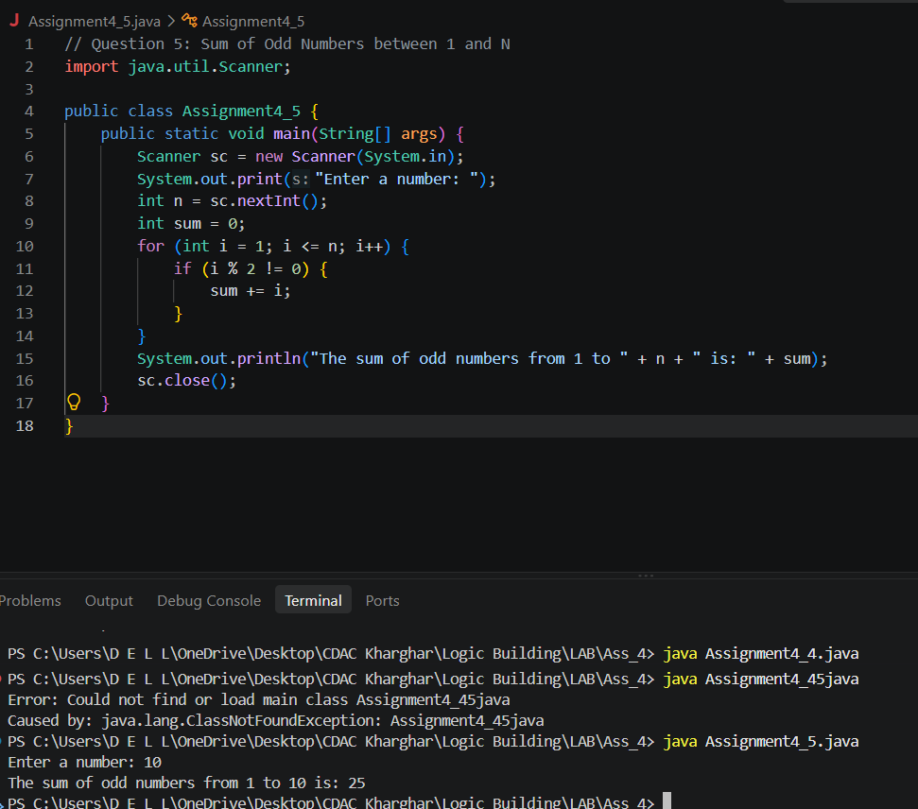
Question 6: Print All Elements of an Array

Problem Statement:
C-DAC MUMBAI
Write a Java program that uses a for-each loop to print all elements of an integer array. The program should ask the user to input 5 integers, store them in an array, and then print all the elements using a for-each loop.

Sample Input:
Enter 5 integers: 3 7 12 5 8

Expected Output:
3 7 12 5 8

Code:

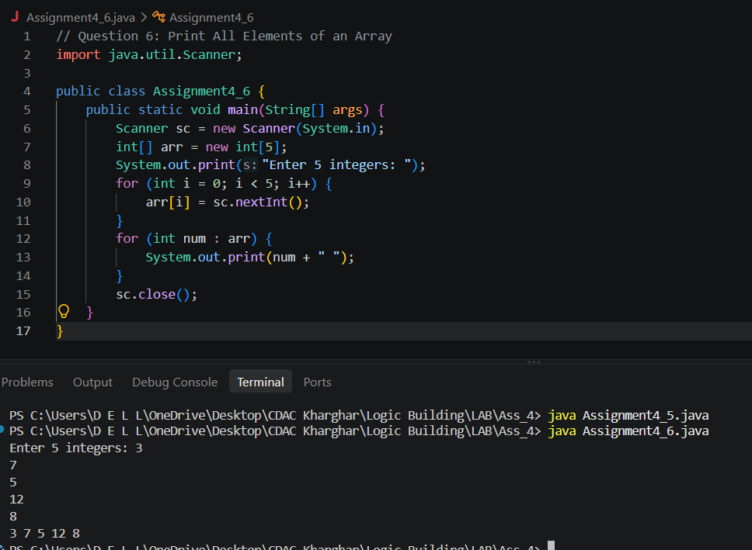

Question 7: Find the Sum of All Elements in an Array

Problem Statement:
Write a Java program that uses a for-each loop to calculate the sum of all elements in a given integer array. The program should ask the user to input 5 integers, store them in an array, and then compute the sum of these numbers using the for-each loop.

Sample Input:
Enter 5 integers: 4 6 8 2 10

Expected Output:
The sum of all numbers is: 30

Code:

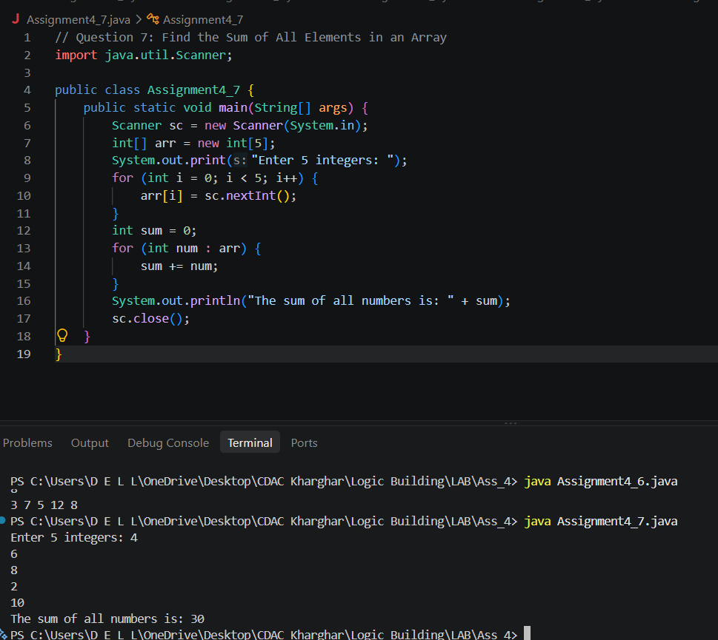

Question 8: Print All Names in a String Array

Problem Statement:
Write a Java program that uses a for-each loop to print all the names stored in a String array. The program should ask the user to input 4 names, store them in an array, and then print each name using the for-each loop.

Sample Input:
Enter 4 names: Manoj Aditya Shilbhushan Shweta

Expected Output:
Manoj Aditya Shilbhushan Shweta
Code:
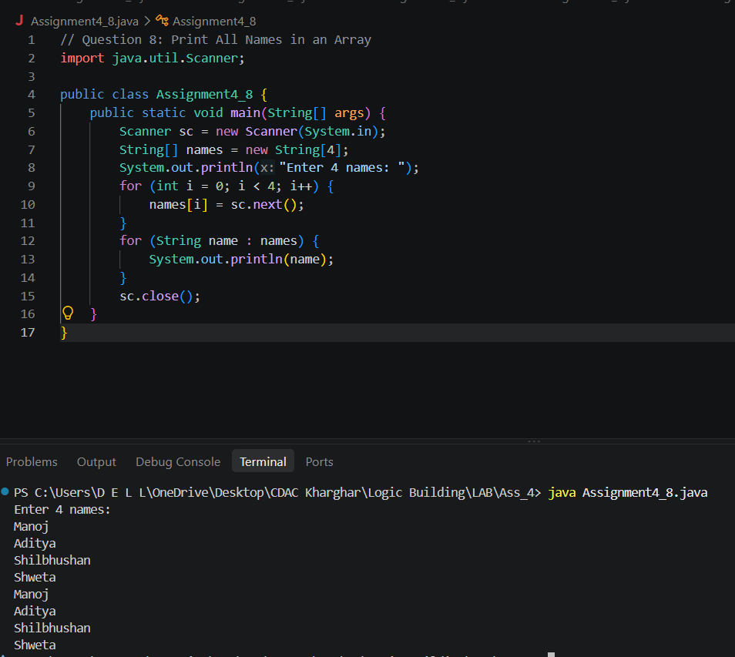

Question 9: Find the Largest Element in an Array

Problem Statement:
Write a Java program that asks the user to input 5 integers, stores them in an array, and then finds and prints the largest element in the array. (Explore in-built method to solve this)

Sample Input:
Enter 5 integers: 12 45 67 23 89

Expected Output:
The largest element is: 89

Code:

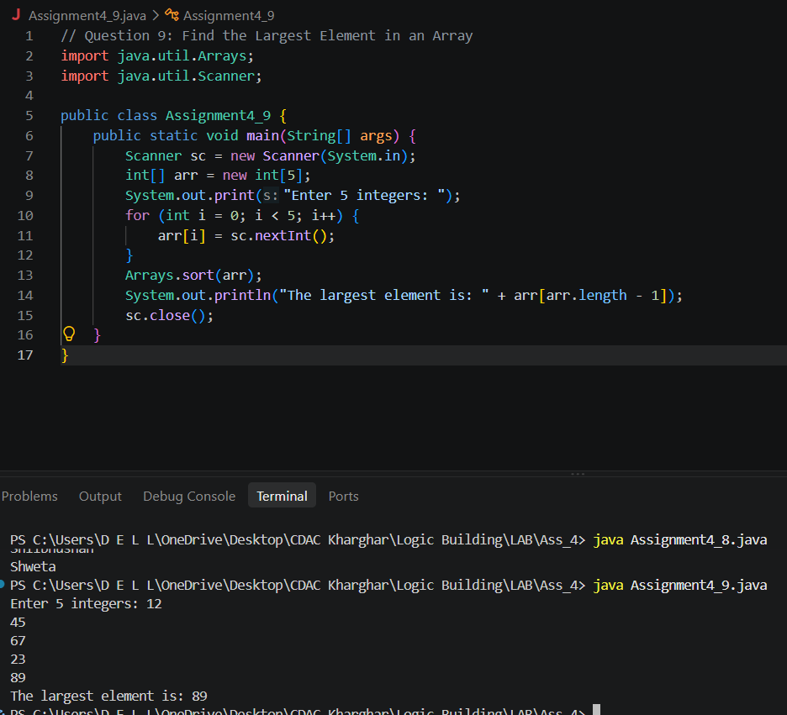
Question 10: Find the Average of Elements in an Array

Problem Statement:
C-DAC MUMBAI
Write a Java program that asks the user to input 5 integers, stores them in an array, and then calculates and prints the average of the elements in the array.

Sample Input:
Enter 5 integers: 10 20 30 40 50

Expected Output:
The average of the numbers is: 30.0

Code:
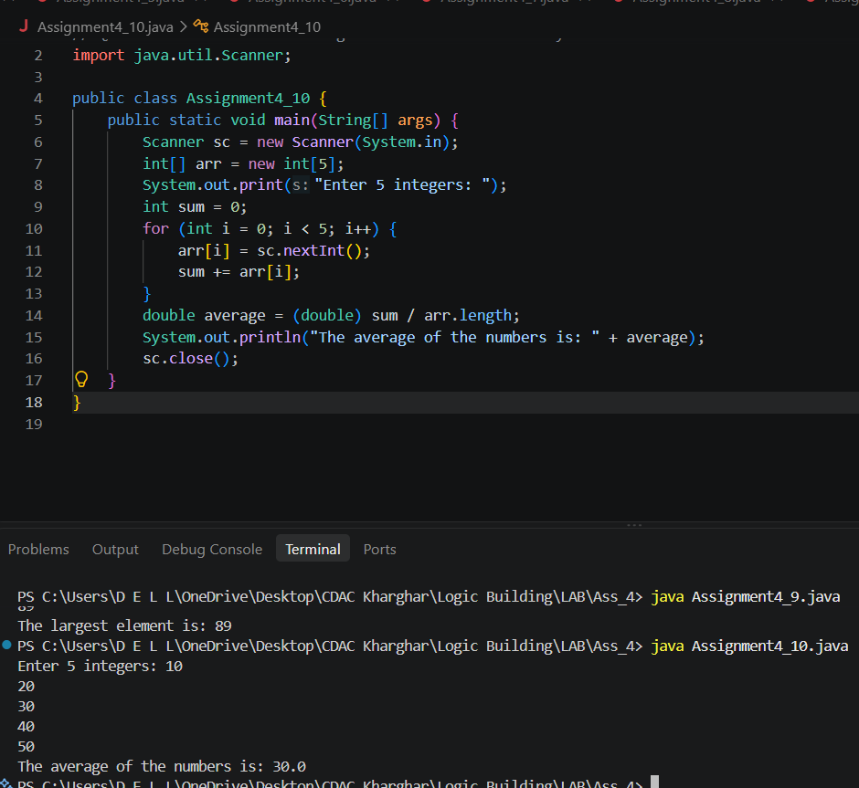

Question 11: Count Positive and Negative Numbers in an Array

Problem Statement:
Write a Java program that asks the user to input 6 integers, stores them in an array, and then counts how many positive and negative numbers are present in the array.

Sample Input:
Enter 6 integers: -5 3 7 -2 0 8

Expected Output:
Positive numbers: 3
Negative numbers: 2

Code:

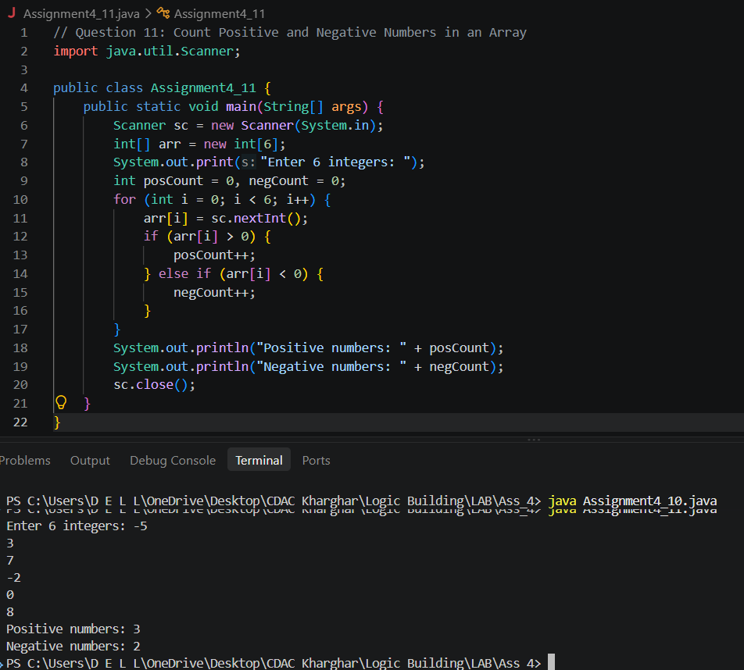

Question 12: Sort an Array in Ascending Order

Problem Statement:
Write a Java program that asks the user to input 5 integers, stores them in an array, and then sorts the array in ascending order using the Arrays.sort() method. After sorting, print the sorted array.

Sample Input:
Enter 5 integers: 12 45 23 8 90

Expected Output:
Sorted array: 8 12 23 45 90

Code:

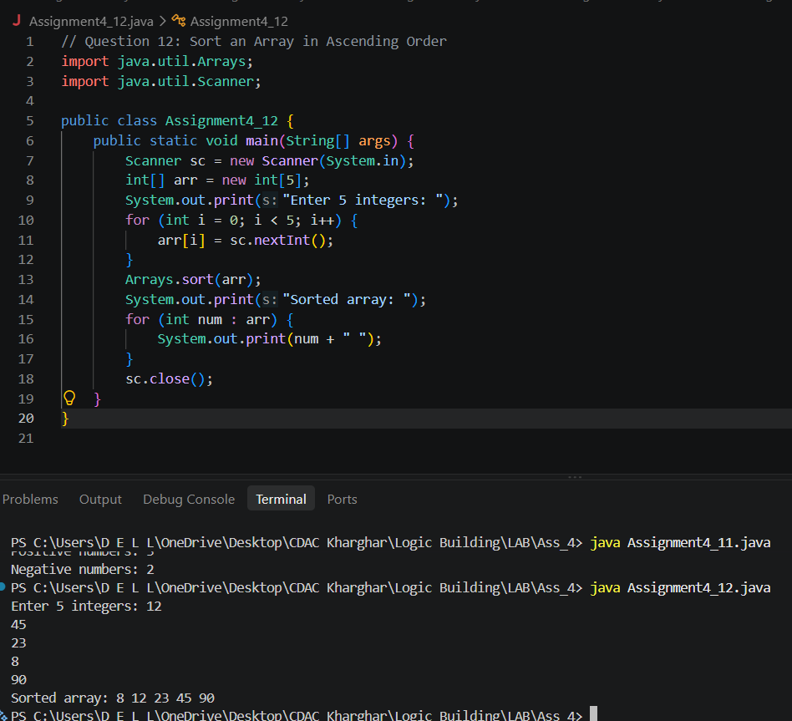

Question 13: Check if an Array Contains a Specific Element

Problem Statement:
Write a Java program that asks the user to input 5 integers, stores them in an array, and then checks whether a specific number (input by the user) is present in the array using the Arrays.asList() method. If the number is found, print "Found", otherwise print "Not Found".

Sample Input:
Enter 5 integers: 10 20 30 40 50 Enter the number to search: 30

Expected Output:
Found

Code:
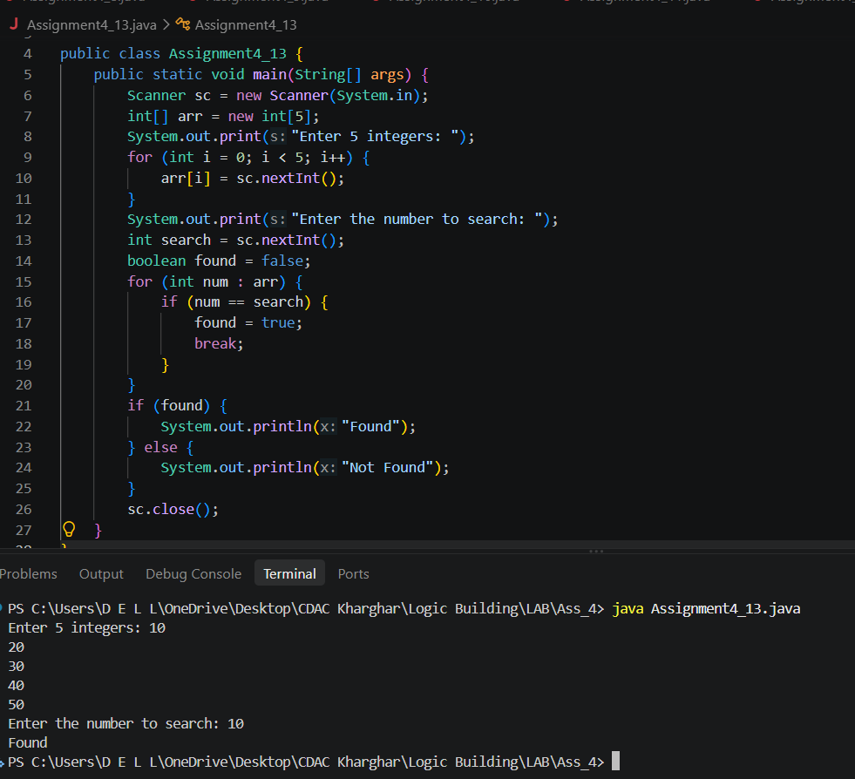

Question 14: Find the Index of an Element in an Array

Problem Statement:
C-DAC MUMBAI
Write a Java program that asks the user to input 5 integers, stores them in an array, and then finds the index of a specific number (input by the user) using the Arrays.binarySearch() method. If the number is found, print the index, otherwise print "Not Found".

Sample Input:
Enter 5 integers: 5 10 15 20 25 Enter the number to search: 15

Expected Output:
The number 15 is found at index 2

Code:
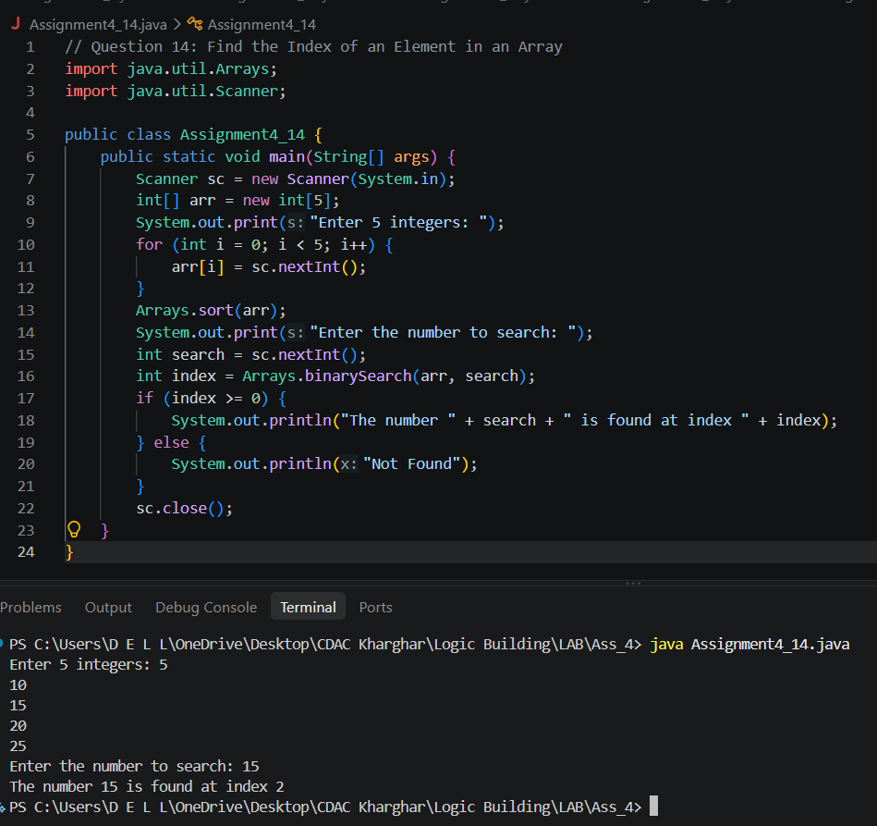

Question 15:Write a program to print the following pattern:
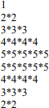
Code:
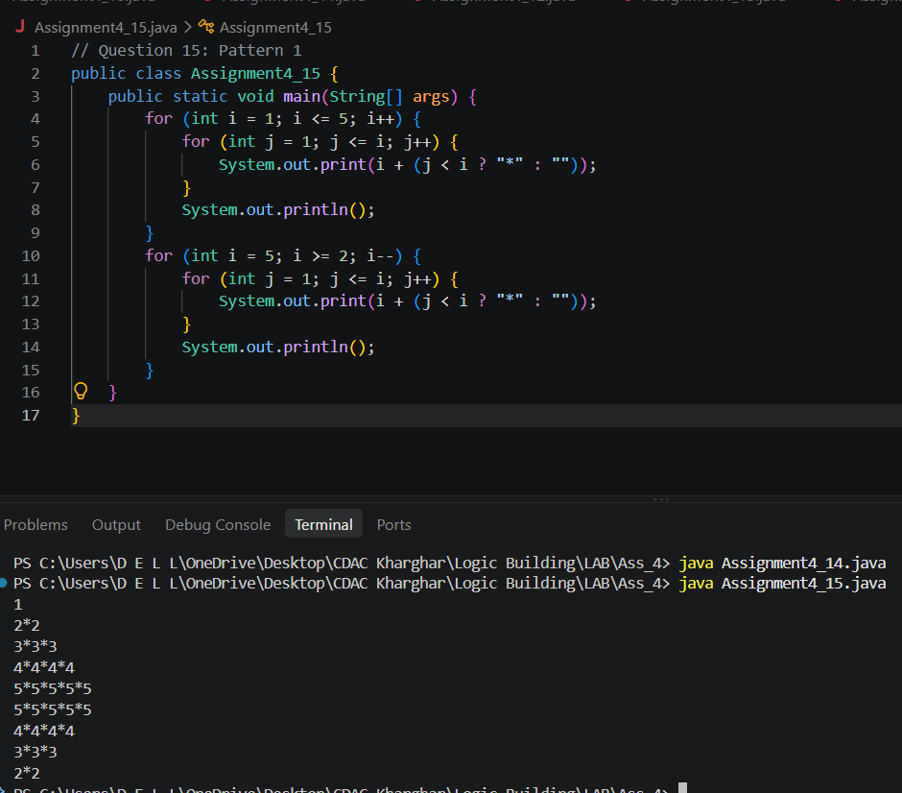

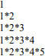
Question 16: Write a program to print the following pattern:

Code:
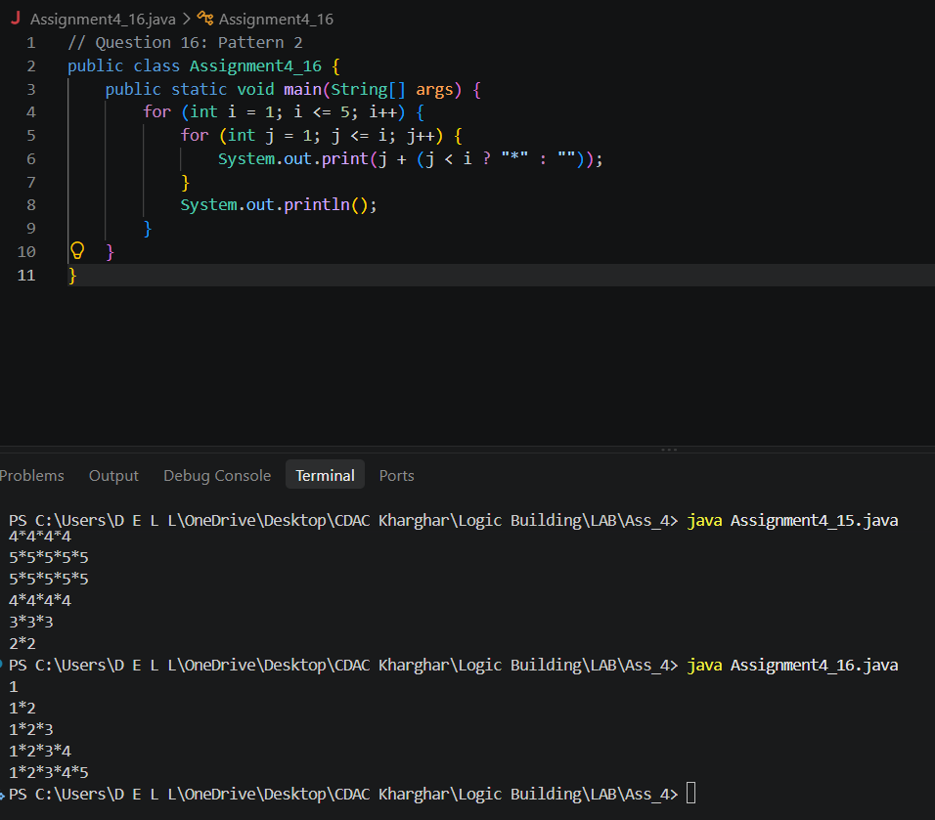

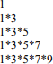
Question 17: Write a program to print the following pattern:

Code:

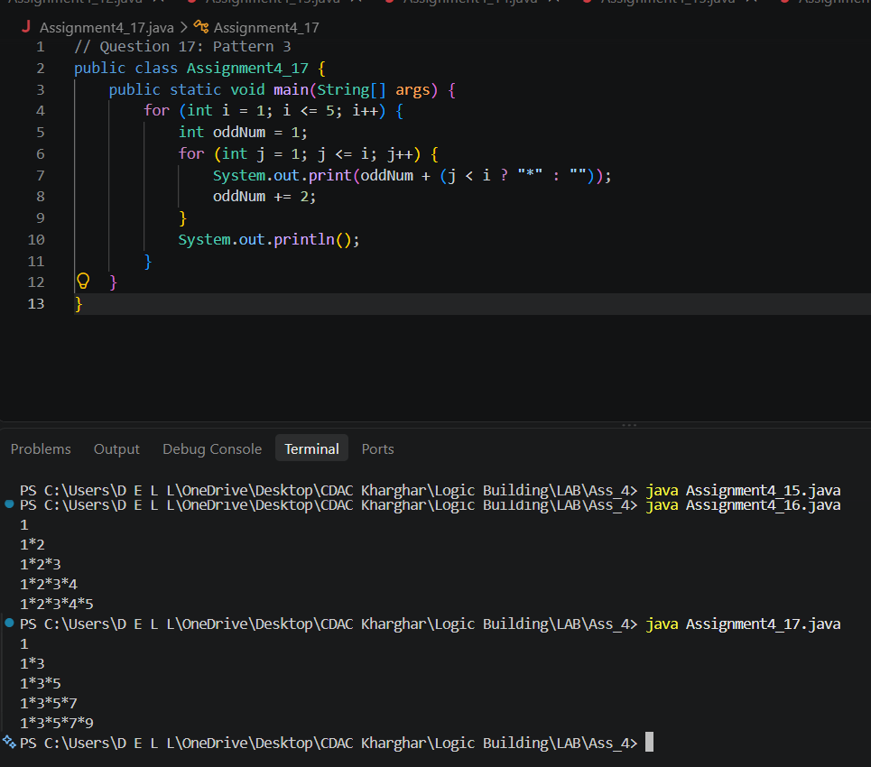

Question 18: Write a program to print the following pattern:

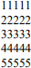

Code:

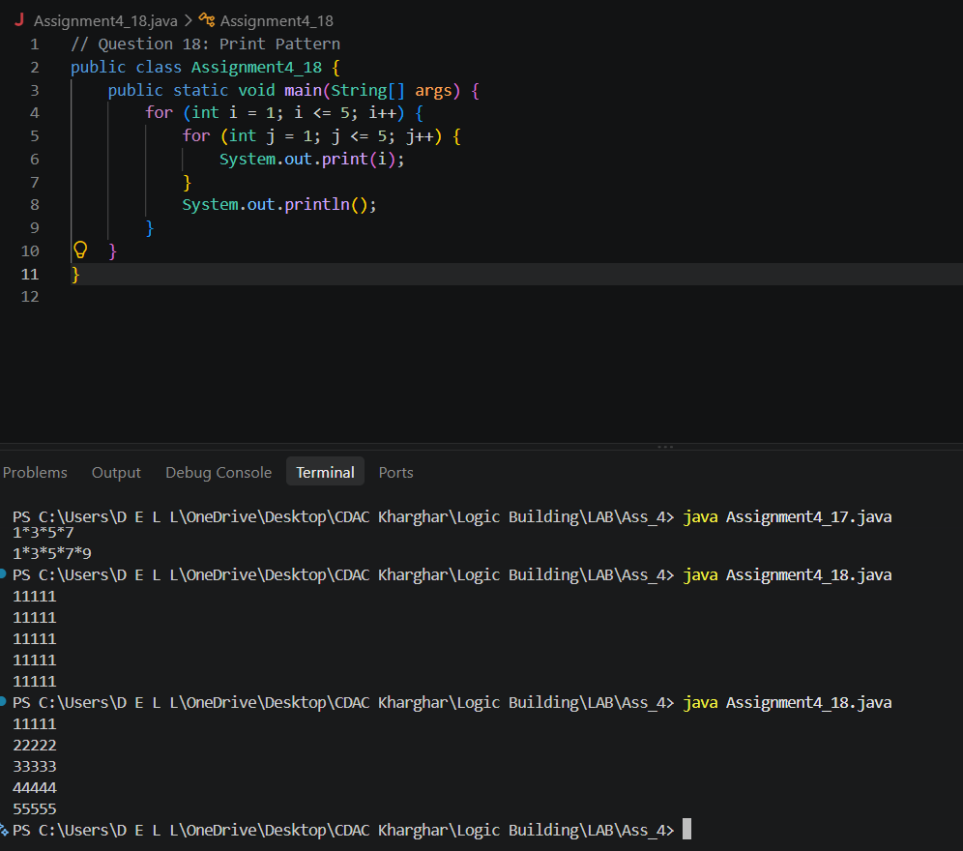
C-DAC MUMBAI

Question 19: Write a program to print the following pattern:
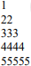
Code:
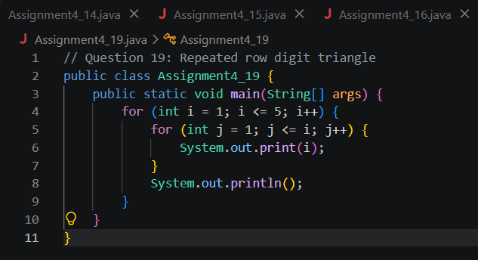

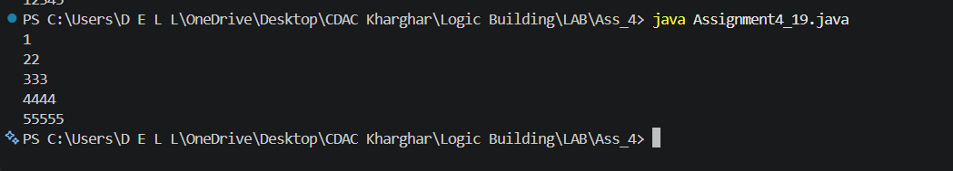

Question 20: Write a program to print the following pattern:
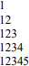
Code:

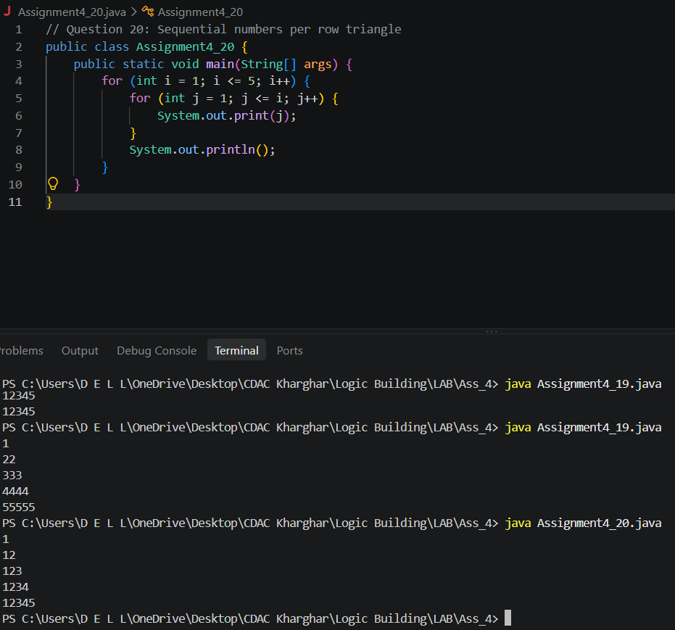

Question 21: Write a program to print the following pattern:
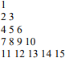
Code:

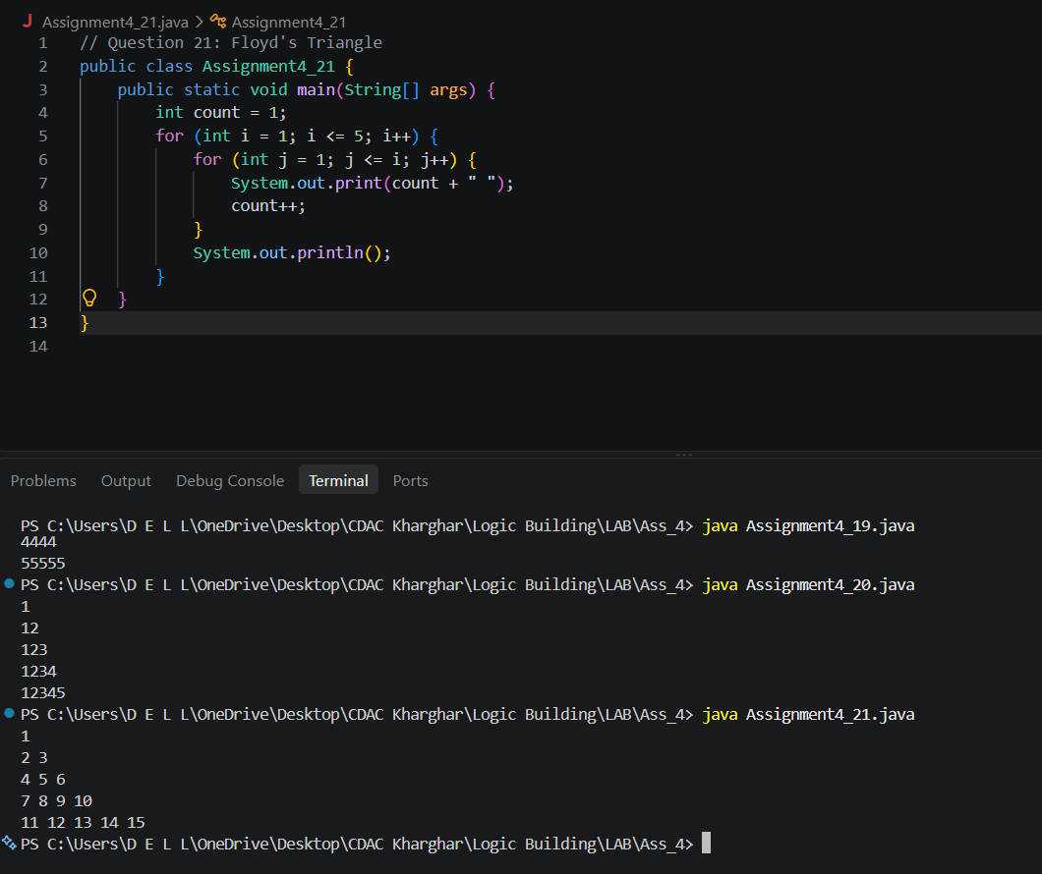

Question 22: Write a program to print the following pattern:
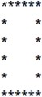

Code:
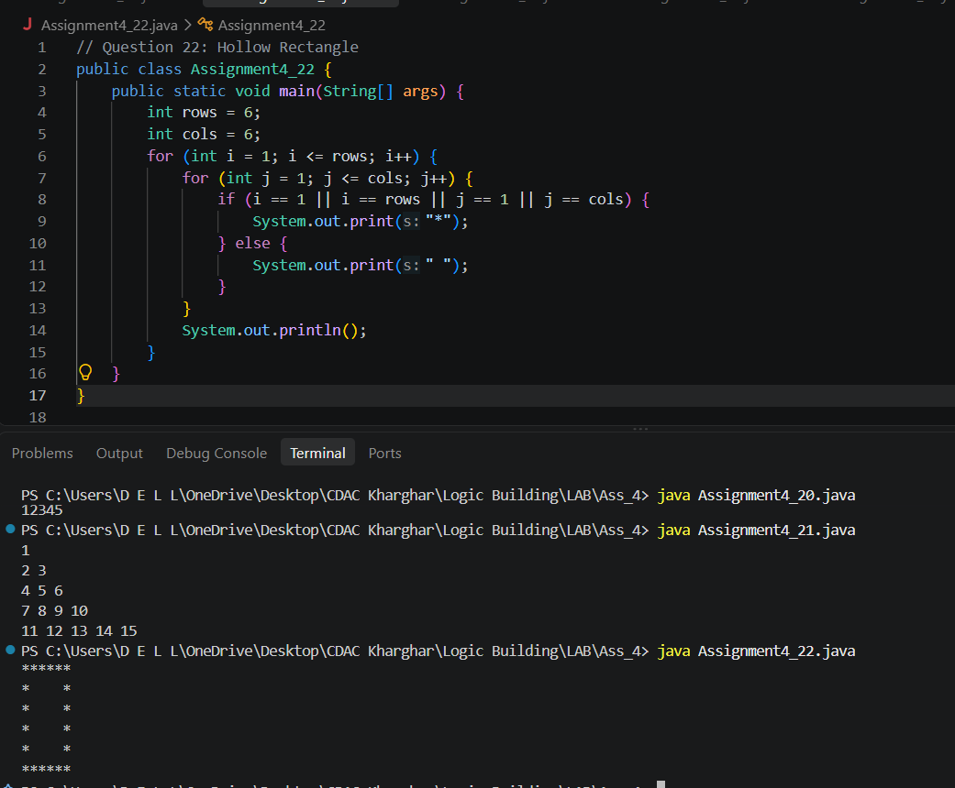

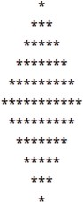
Question 23: Write a program to print the following pattern

Code:
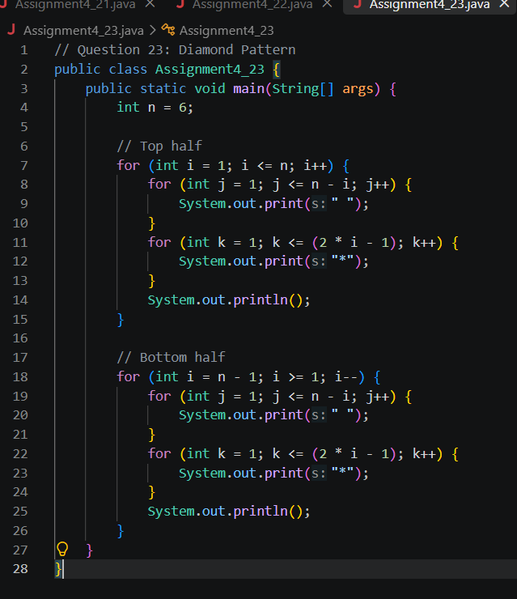

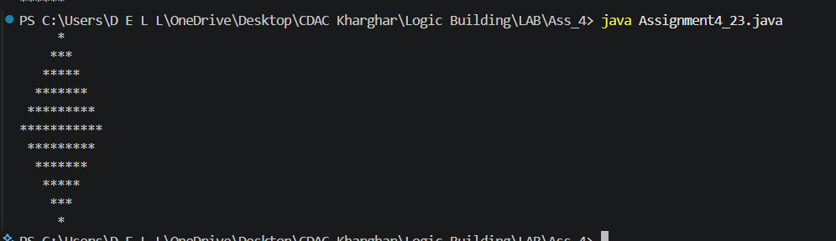
Question 24: Reverse a String
Problem Statement:
C-DAC MUMBAI
Write a Java program that asks the user for a string and then prints the reverse of that string.

Sample Input:
Enter a string: hello

Expected Output:
Reversed string: olleh

Code:
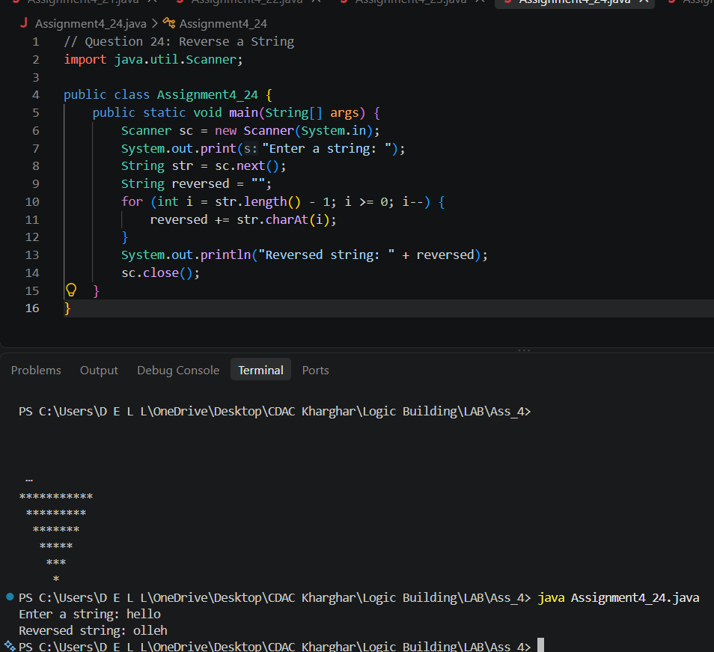

Question 25: Count Vowels in a String Problem Statement:
Write a Java program that asks the user for a string and counts the number of vowels (a, e, i, o, u) in the string. The program should then print the total number of vowels.

Sample Input:
Enter a string: programming

Expected Output:
The number of vowels in 'programming' is: 3
Code:
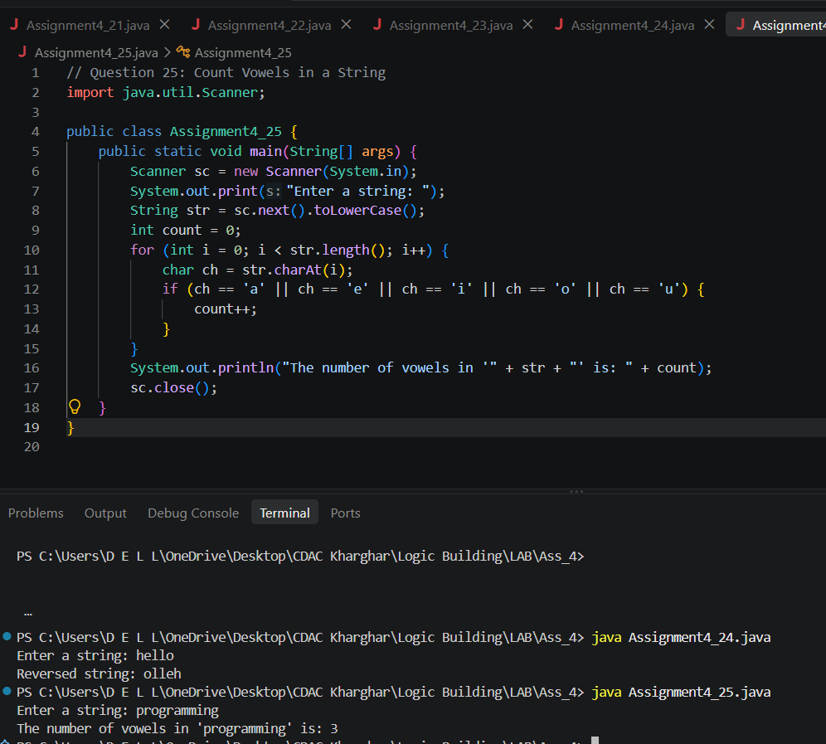

Question 26: Check if a String is a Palindrome Problem Statement:
Write a Java program that asks the user for a string and checks whether the string is a palindrome. A palindrome is a string that reads the same backward as forward (ignoring spaces and punctuation).

Sample Input:
Enter a string: madam

Expected Output:
The string 'madam' is a palindrome.
Code:

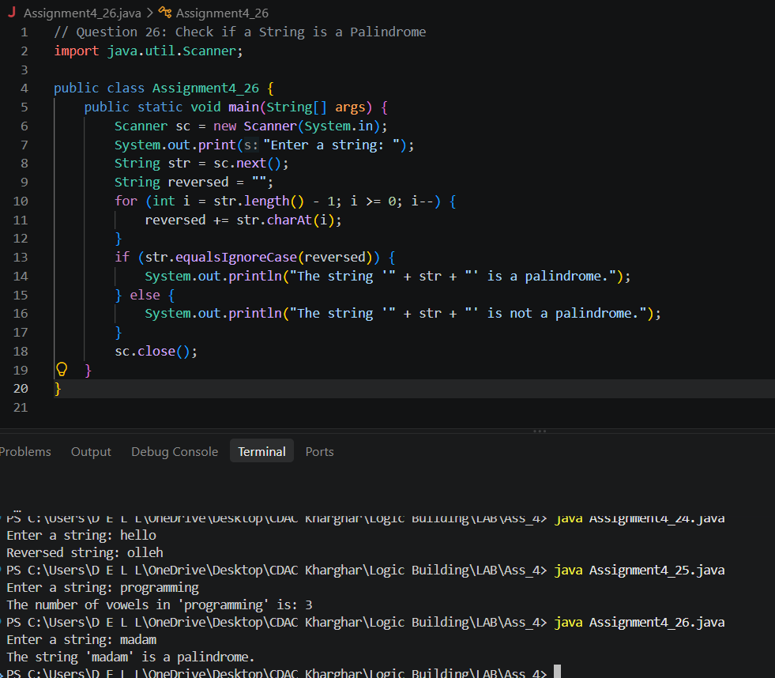

Question 27: String Literal and Object Creation Problem Statement:
Write a Java program that creates two string variables using string literals with the same content. Then, print whether both variables point to the same object.

Code Example:
String str1 = "hello"; String str2 = "hello";

Expected Output:
Both variables point to the same object: true

Code:

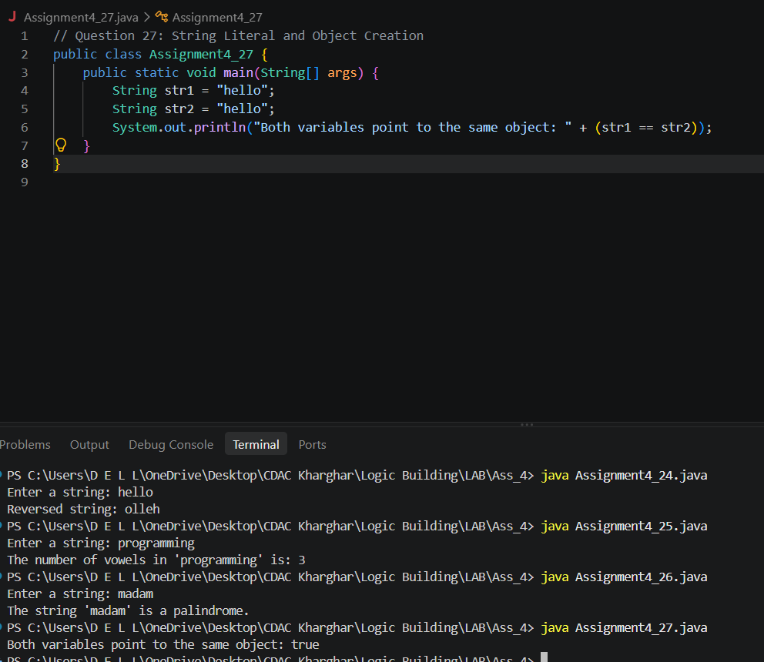
Question 28: String Creation with new Keyword

Problem Statement:
C-DAC MUMBAI
Write a Java program that creates two string objects using the new keyword with the same content. Then, print whether both objects are the same using the == operator and the .equals() method.

Code Example:
String str1 = new String("hello"); String str2 = new String("hello");

Expected Output: Using == : false Using .equals(): true

Code:

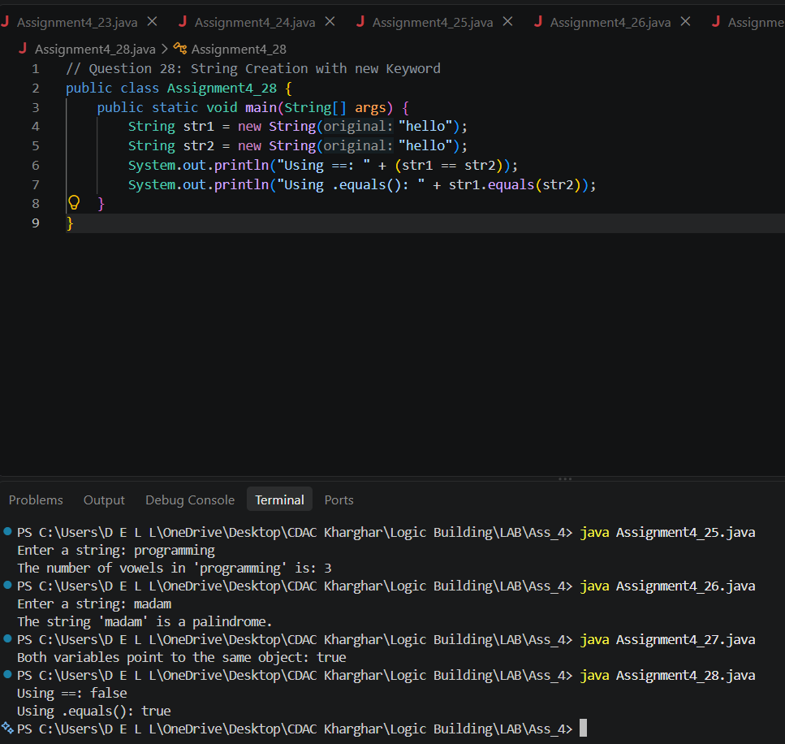

Question 29 : String Concatenation and Object Creation Problem Statement:

Write a Java program that concatenates two strings using the + operator. Print whether the concatenated string is a new object or a reference to an existing string object using the == operator.

Code Example:
String str1 = "hello"; String str2 = "world"; String str3 = str1 + str2;

Expected Output:
Is str3 pointing to the same object as str1? False

Code:
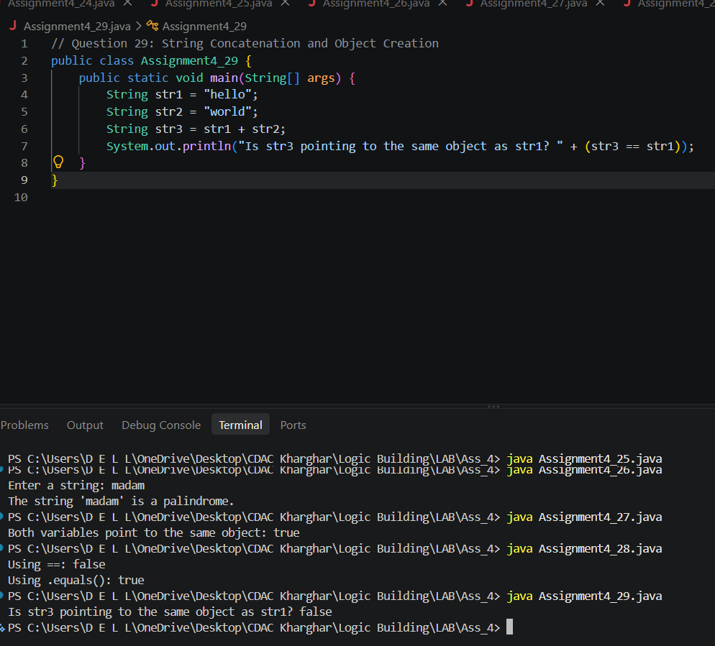

Question 30: String Pool with intern() Method Problem Statement:
Write a Java program that creates a string using the new keyword and then calls the intern() method. Print whether the interned string is pointing to the same object as the original string literal.

Code Example:
String str1 = new String("hello"); String str2 = str1.intern();
String str3 = "hello";

Expected Output:
Is str2 and str3 pointing to the same object? True

Code:
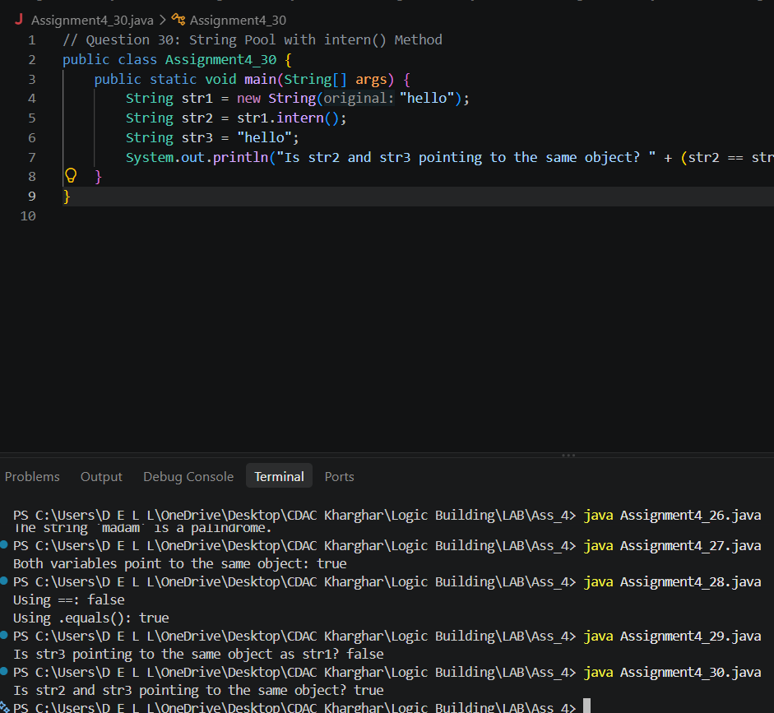

Question 31: Multiple String Literals with Same Content

Problem Statement:
C-DAC MUMBAI
Write a Java program that declares three string literals with the same content and prints whether all three strings refer to the same object using the == operator.

Code Example:
String str1 = "java"; String str2 = "java"; String str3 = "java";

Expected Output:
All strings point to the same object: true

Code:
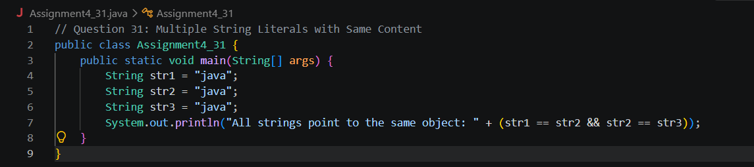

More Pattern (to build more logic-If you get extra time, toh hi karna):https://www.geeksforgeeks.org/java/java-pattern-programs/

NOTE: CONGRATULATIONS WHO COMPLETED THIS..
(If you completed this complete assignment - Write in the whatsApp group “Yeh Dil Mange More”)

